Project Report
Retail Store Sales Insights and Prediction Model
Submitted By:
Cirimamilla chandrika
Course:
Data science Internship
Organization:
Nyeras Technologies
Tools Used:
Python, Google, Colab, Pandas, Numpy, Matplotlib, Seaborn, Scikit-learn
Submission Date:

Certificate
This is to certify that the project titled "Retail Store Sales Insights and Prediction Model" is an original work carried out by Chandrika Cirimamilla as part of the Data Science Internship at Nyeras Technologies. The project was completed using Python, Google Colab, and Machine Learning techniques under the internship guidelines.

Acknowledgement
I would like to express my sincere gratitude to Nyeras Technologies for providing me with the opportunity to work on this project. I also thank my mentors for their valuable guidance and support throughout the internship. This project helped me improve my knowledge of data analysis, machine learning, and Python programming.

TABLE OF CONTENTS
1. Abstract ....................................................... 1
2. Introduction ................................................. 2
3. Objectives .................................................... 3
4. Dataset Description ..................................... 4
5. Tools and Technologies Used ....................... 5
6. Methodology ............................................... 6
7. Data Preprocessing ...................................... 7
8. Exploratory Data Analysis (EDA) ................... 8
9. Correlation Analysis .................................... 10
10. Model Building ......................................... 11
11. Model Evaluation ...................................... 12
12. Actual vs Predicted Sales ........................... 13
13. Results ..................................................... 14
14. Conclusion ............................................... 15
15. Future Scope ............................................ 16
16. References .............................................. 17

Abstract
This project focuses on analyzing retail store sales data and predicting future sales using machine learning techniques. The dataset was cleaned, explored, and analyzed using Exploratory Data Analysis (EDA). Correlation analysis was performed to understand relationships among variables. A Random Forest Regression model was developed to predict sales. The model achieved an R² Score of 0.9927, demonstrating excellent prediction performance. This project shows how data analytics and machine learning can help businesses improve sales forecasting and decision-making.

Introduction
Retail businesses generate a large amount of sales data every day. Analyzing this data helps businesses understand customer purchasing behavior, identify sales trends, and make better business decisions. Sales prediction is an important task that enables organizations to forecast future sales and manage inventory, marketing, and resources efficiently.

In this project, retail store sales data was analyzed using Python and various data analysis techniques. The dataset was cleaned, explored, and visualized using Exploratory Data Analysis (EDA). A Random Forest Regression model was developed to predict sales ba
sed on different features. The project demonstrates the practical application of machine learning in retail sales forecasting.

Objectives
• To analyze retail store sales data.
• To perform data cleaning and preprocessing.
• To explore the dataset using Exploratory Data Analysis (EDA).
• To identify relationships between different variables using correlation analysis.
• To build a Random Forest Regression model for sales prediction.
• To evaluate the model using MAE, MSE, RMSE, and R² Score.
• To provide insights that support better business decision-making.

Dataset Description
The dataset contains retail store sales information, including customer details, product information, sales values, discounts, profit, quantity, payment methods, and regional information. The dataset was used to analyze sales patterns and build a machine learning model for predicting future sales.

Dataset features
Column Name | Description
Order_ID | Unique order identifier
Customer_ID | Unique customer identifier
Order_Date | Date of purchase
Region | Sales region
City | Customer city
Category | Product category
Product | Product name
Quantity | Number of items purchased
Unit_Price | Price per item
Discount | Discount applied
Sales | Total sales amount (Target Variable)
Profit | Profit earned
Payment_Method | Payment type
Customer_Age | Customer age
Gender | Customer gender

Tools and technologies used
Programming Language : Python
Development Environment : Google Colab
Libraries Used :
• Pandas
• NumPy
• Matplotlib
• Seaborn
• Scikit-learn
Machine Learning Algorithm :
• Random Forest Regression

Methodology
The project was completed using a systematic data analysis and machine learning approach. First, the dataset was imported into Google Colab using the Pandas library. The data was explored to understand its structure, identify missing values, and check data types. Data preprocessing techniques such as handling missing values, removing unnecessary columns, and encoding categorical variables were applied.
Exploratory Data Analysis (EDA) was performed using statistical summaries and visualizations to understand the distribution of data and relationships between variables. A correlation heatmap was generated to identify the strength of relationships among numerical features.
After preprocessing, the dataset was divided into training and testing sets. A Random Forest Regression model was trained using the training data to predict retail sales. Finally, the model was evaluated using performance metrics such as Mean Absolute Error (MAE), Mean Squared Error (MSE), Root Mean Squared Error (RMSE), and R² Scor

Data preprocessing
Data preprocessing is an important step in machine learning. The dataset was cleaned and prepared before training the model.
The preprocessing steps included:
• Importing the dataset into Google Colab
• Checking dataset information using df.info().
• Identifying missing values using isnull().
• Removing duplicate records.
• Encoding categorical variables into numerical values using LabelEncoder.
• Selecting the required features for model training.
• Splitting the dataset into training and testing sets.

Exploratory data analysis (EDA)
Exploratory Data Analysis was performed to understand the characteristics of the retail sales dataset. Various statistical summaries and visualizations were created to identify trends, distributions, and relationships among variables.

The following visualizations were generated:
• Sales Distribution
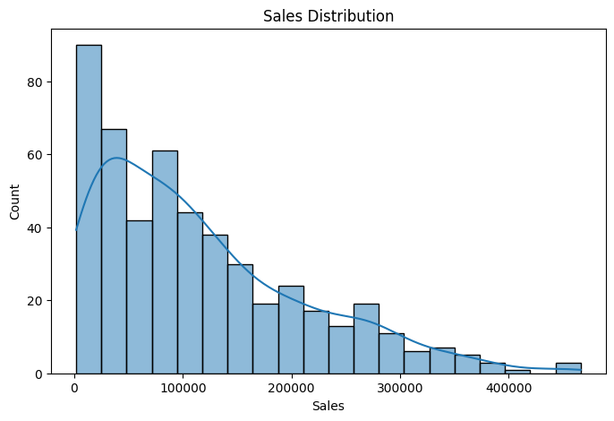

• Category-wise Sales Analysis
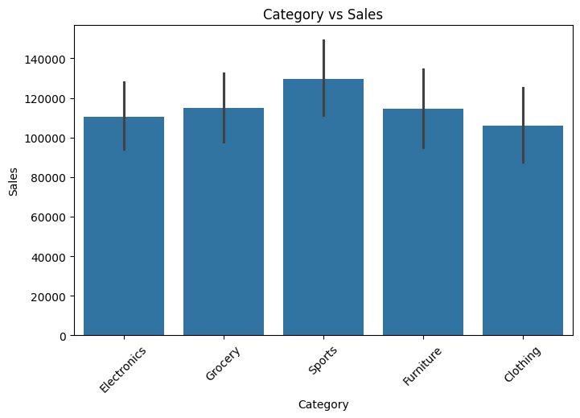

• Region-wise Sales Analysis
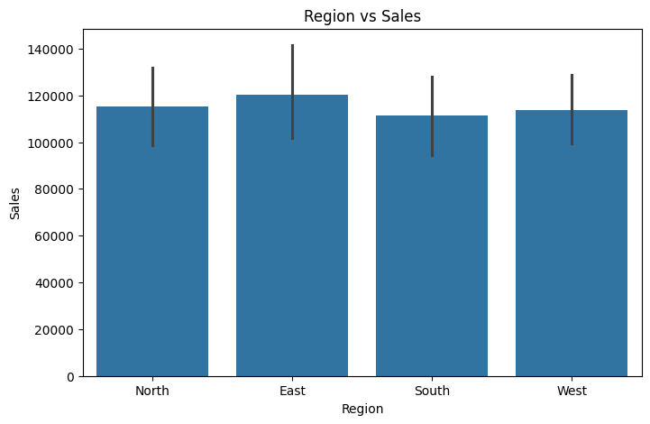

• payment method count
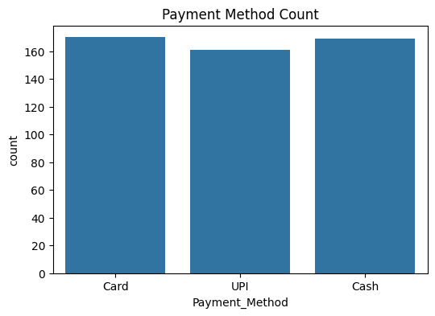

• Correlation Heatmap
These visualizations helped in identifying important business insights and understanding the factors affecting sales.

Correlation analysis
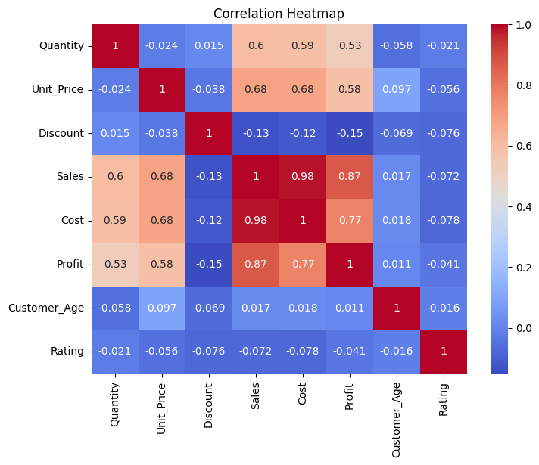

Actual vs predicted sales
The Random Forest Regression model was used to predict sales values from the test dataset. The predicted values were compared with the actual sales values to evaluate the model's performance. The comparison shows that the predicted sales are very close to the actual sales, indicating that the model has learned the underlying patterns effectively. The high R² Score (0.9927) further confirms the excellent accuracy of the model.
A correlation heatmap was generated to measure the relationship between numerical variables in the dataset. The heatmap helped identify both positive and negative correlations between features.
Highly correlated variables indicate a strong relationship, while weak correlations suggest limited influence on each other. Correlation analysis supports feature selection and improves the performance of machine learning models by identifying the most relevant variables.
S.No | Actual Sales | Predicted Sales
1 | 44,928.0 | 45,818.3840
2 | 232,254.4 | 228,261.1855
3 | 236,439.0 | 251,397.8210
4 | 24,591.0 | 25,999.3610
5 | 72,859.5 | 68,579.5640
6 | 135,136.4 | 124,944.3795
7 | 79,093.2 | 77,466.2265
8 | 221,930.0 | 223,444.1555
9 | 51,217.6 | 53,374.4830
10 | 114,487.2 | 117,821.4335

Model building
After preprocessing the data, the dataset was divided into training and testing sets using the train_test_split() function. A Random Forest Regression algorithm was selected because it provides accurate predictions and handles complex relationships between variables effectively.
The model was trained using the training dataset and then tested using the testing dataset. After training, the model was used to predict retail sales for unseen data.

Model evaluation
The performance of the Random Forest Regression model was evaluated using standard regression metrics.
The evaluation metrics obtained are:
• Mean Absolute Error (MAE): 4656.20
• Mean Squared Error (MSE): 66,595,864.18
• Root Mean Squared Error (RMSE): 8160.63
• R² Score: 0.9927
The R² Score of 0.9927 indicates that the model explains approximately 99.27% of the variation in the sales data, demonstrating excellent predictive performance.
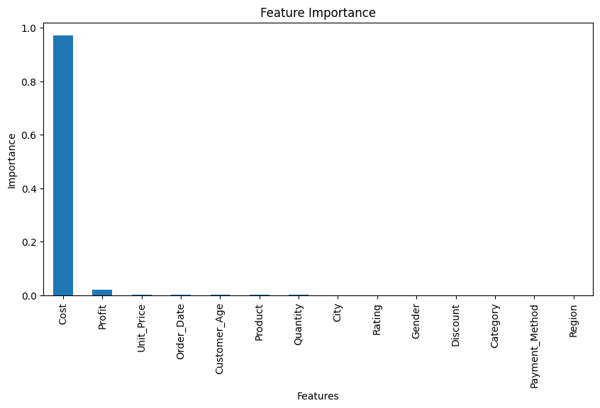

Results
The Random Forest Regression model successfully predicted retail store sales with high accuracy. The exploratory data analysis helped identify important sales trends and relationships between different variables. The evaluation results confirmed that the model performed well and can be used for sales forecasting. The project demonstrates the practical use of machine learning in analyzing retail business data and supporting better business decisions.

Conclusion
This project successfully analyzed retail store sales data using Python, Google Colab, and machine learning techniques. Data preprocessing, exploratory data analysis, feature selection, and model training were completed successfully. The Random Forest Regression model achieved an R² Score of 0.9927, indicating excellent prediction accuracy. This project demonstrates how machine learning can be applied to improve retail sales forecasting and support effective business decision-making.

Future scope
• Improve the model using larger real-world datasets.
• Compare the performance of different machine learning algorithms.
• Develop a real-time sales prediction dashboard using Power BI or Streamlit.
• Include additional business factors such as holidays, promotions, and seasonal trends to improve prediction accuracy.
• Deploy the model as a web application for business use.

References
1. Scikit-learn Documentation – https://scikit-learn.org/
2. Pandas Documentation – https://pandas.pydata.org/
3. NumPy Documentation – https://numpy.org/
4. Matplotlib Documentation – https://matplotlib.org/
5. Seaborn Documentation – https://seaborn.pydata.org/
6. Python Official Documentation – https://www.python.org/

